**HIMPUNAN**

1. A.) {0, 2, 4, 6, 8}

B.) {1, 3, 5, 9, 15, 45}

C.) {2, 3, 5, 7, 11, 13, 17, 19, 23, 29}

D.) {m, a, n, c, h, e, s, t, r}

1. A.)
2. {p, q, r}
3. {p, q, s}
4. {q, r, s}
5. {p, r, s}

B.) P(X) = { ∅, {p}, {q}, {r}, {s}, {p, q}, {p, r}, {p, s}, {q, r}, {q, s}, {r, s}, {p, q, r}, {p, q, s}, {p, r, s}, {q, r, s}, {p, q, r,s} }

1. {i, l}, {i, u}, {i, s}, {l, u}, {l, s}, {u, s} = 6 🡪 berkadinalitas 2

S = {0, 1, 2, 3, 4, 5, 6, 7, 8, 9, 10}

1. A.) $S-(D ∪E ∪F)$

{0, 1, 2, 3, 4, 5, 6, 7, 8, 9, 10} - {1, 2, 3, 4, 5, 6, 7, 8} = {0, 9, 10}

B.) $\left(S-D\right)∩\left(S-E\right)∩\left(S-F\right)$ = {0, 9, 10}

(S – D) = {0, 1, 2, 3, 4, 5, 9, 10}

(S – E) = {0, 4, 6, 7, 8, 9, 10}

(S – F) = {0, 1, 2, 3, 6, 9, 10}

C.) S / {0, 1, 2, 3, 4, 5, 6, 7, 8, 9, 10}

D.) ∅

1. S = 500

Mt = 329

Mb = 186

Mt U Mb = 83

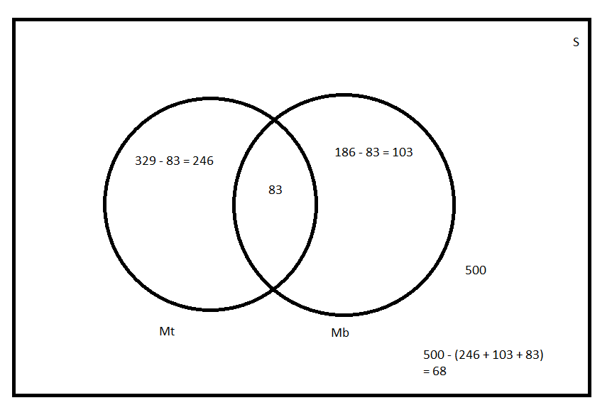

1. S = 48

v = 24

b = 27

t = 25

v U b = 12

v U t = 11

v U b U t = 7

Tidak suka ke3 nya = 4

